W02 Learning Activity: An Introduction to CSS
Overview
CSS (Cascading Style Sheets) is a rule set language that defines the style and presentation of an HTML document. CSS rules select elements from the document and contain style and layout declarations.
Prepare
Watch the following video:
https://youtu.be/CDQobxknrlE?si=QpI7OHNwLXKFiedX
CSS Syntax
CSS rules are made up of a selector and a declaration block { }. The selector is the HTML element(s) you want to style and the declaration block contains one or more declarations separated by semicolons (;). Each declaration includes a CSS property name and a value, separated by a colon (:). The declaration block is enclosed in curly braces.
CSS Rule Example
The following CSS rule selects all the <h1> elements and sets four properties:
- the background color of all the <h1> elements to dark blue
- the text color of the content of all the <h1> elements to white
- padding or space around the text content of 16 pixels
- the text is aligned to the center of the <h1> block

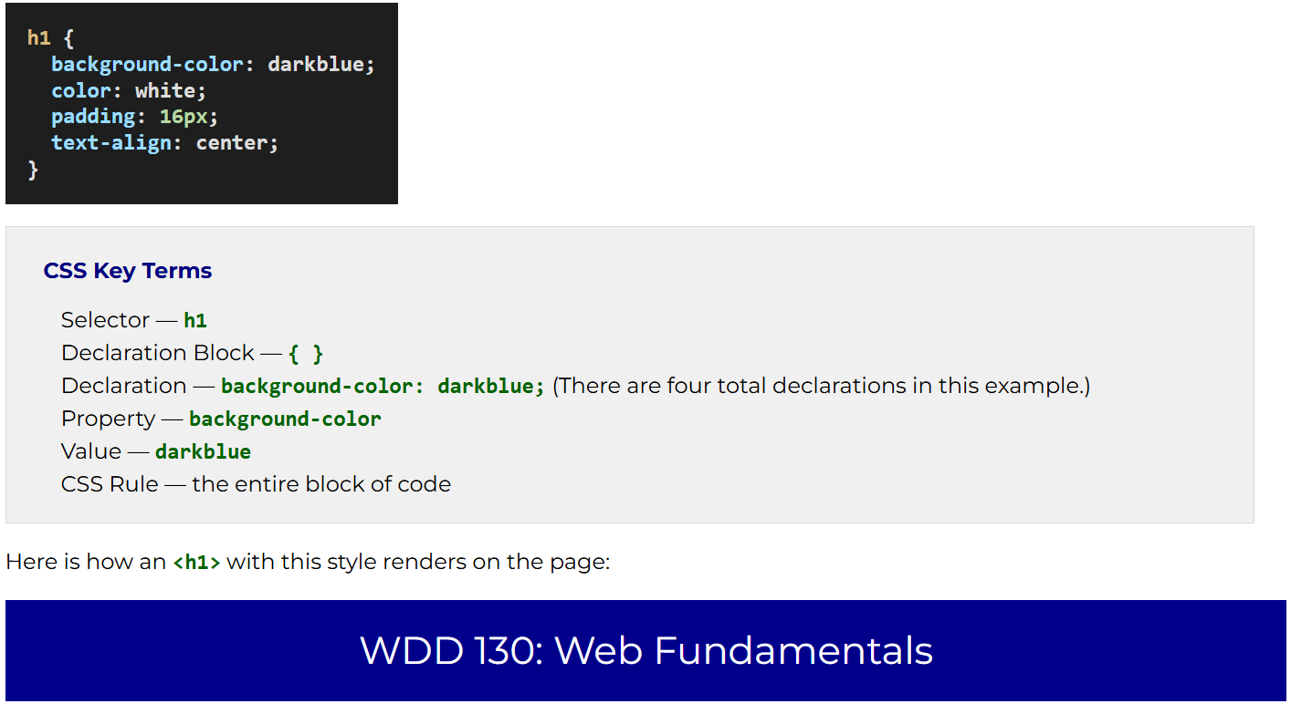
Write some CSS
- Open the styles.css file located in the styles folder of your wdd130 folder.
- Add the following CSS rules:
- nav {
- background-color: darkblue;
- padding: 10px;
}
This CSS rule names the <nav> element as the selected element to apply two style declarations.
  - The background color will be the color "darkblue", which is a valid, named color.
  - Padding, or area between the content and border is set to 10 pixels for readability.
nav a {
color: white;
display: block;
padding: 20px;
}
This CSS rule selects all the <a> (anchor / link) elements in the HTML that are children of the <nav> element and applies the following declarations:
  - The foreground or font color will be white.
  - The display will change from the default of inline to block.
  - Each anchor tag will have padding of 20px;
h1 {
color: darkblue;
}
This CSS rule references the <h1> (heading 1) element as the selected element and applies the following declaration:
  - The foreground, font color is set to darkblue.
img {
width: 150px;
height: auto;
border: 1px solid black;
padding: 2px;
box-shadow: 0 0 30px gray;
}
This CSS rule references all the <img> (image) elements as the selector and applies the following declarations:
  - a set width with a height that will adjust dynamically to fit the image's aspect ratio.
  - A border shortcut that names the width, type of border, and color of the border.
  - Padding between the image and the border.
  - A box shadow around the image border with zero offset and depth of 30px in gray.
p {
padding: 10px;
}
This CSS rule selects all the <p> (paragraph) elements as the selector and applies the following declaration:
  - Padding between the paragraph content and the border is set to 10 pixels.
- Be sure to save your styles.css changes.
Example home page with CSS applied
Link the CSS file to the HTML page
- Open the index.html file and add the following line in the <head> section of the HTML document.
- <link rel="stylesheet" href="styles/styles.css">

- Test the application of the style to your homepage by using Live Server or Five Server. To do this, right mouse click on the file name in the Explorer Panel in VS Code and select Open with Live Server or Five Server.
- Make corrections if needed.
https://www.loom.com/share/160649d321c34b9faa0c691fa94b2ff5
Video demo

